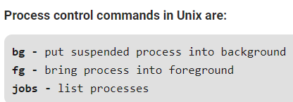

**bg command:**

bg command in linux is used to place foreground jobs in background.

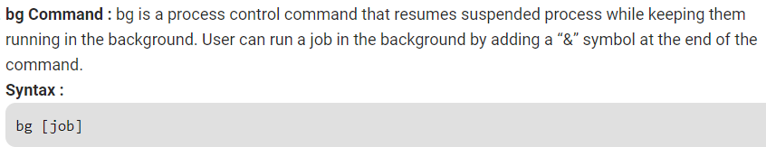

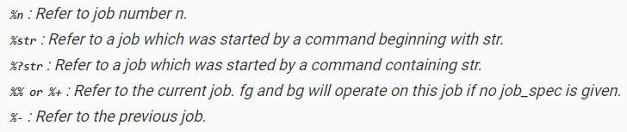

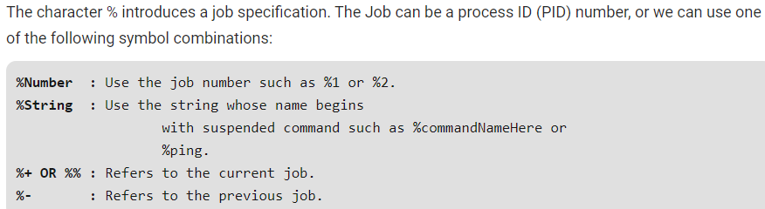

**Options for bg command:**

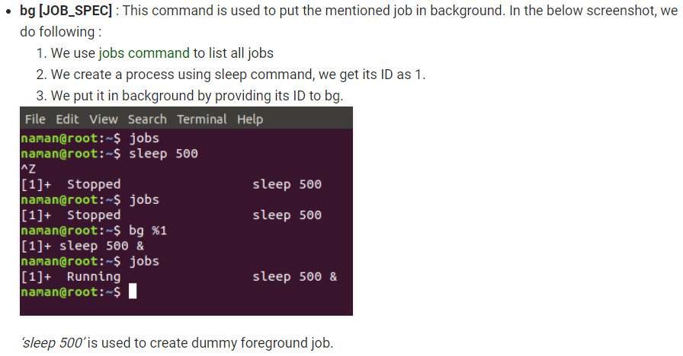



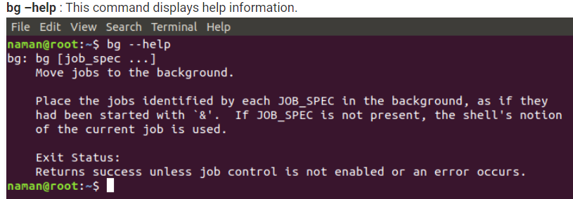

**fg command:**

fg command in linux used to put a background job in foreground.

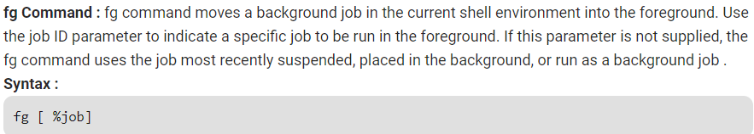

**%job:** Specifies the job that you want to run in the foreground.

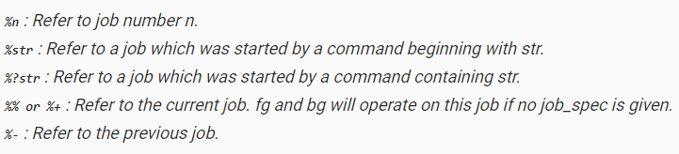

**Options for fg command:**

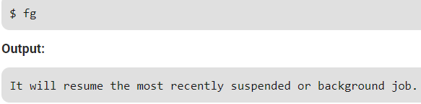

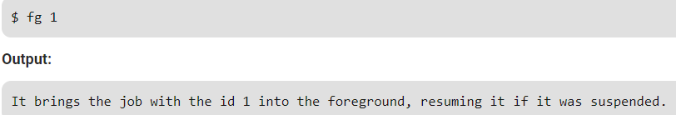

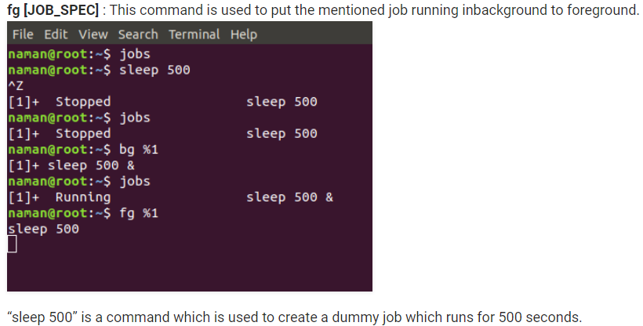

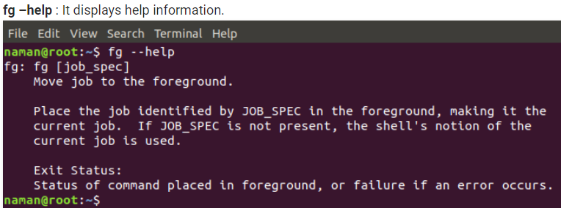

**jobs command:**

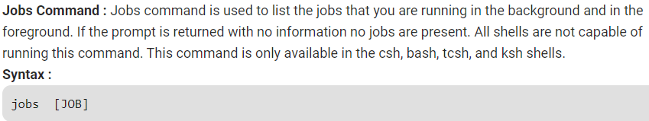

**Options:**

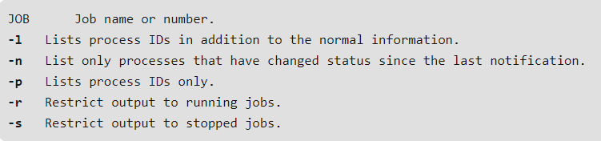

**Examples:**

To display the status of jobs in the current shell



To display the process ID or jobs for the job whose name begins with **“p,”:**

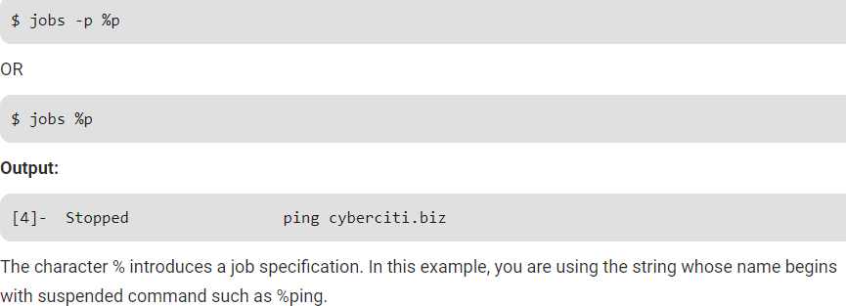

Pass the **-p** option to jobs command to display PIDs only:

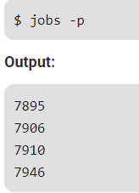

Pass the **-r** option to jobs command to display only running jobs only:

